CREATE TABLE STUDENT3(Reg_No NUMBER(20), Names VARCHAR(38),DOB DATE);

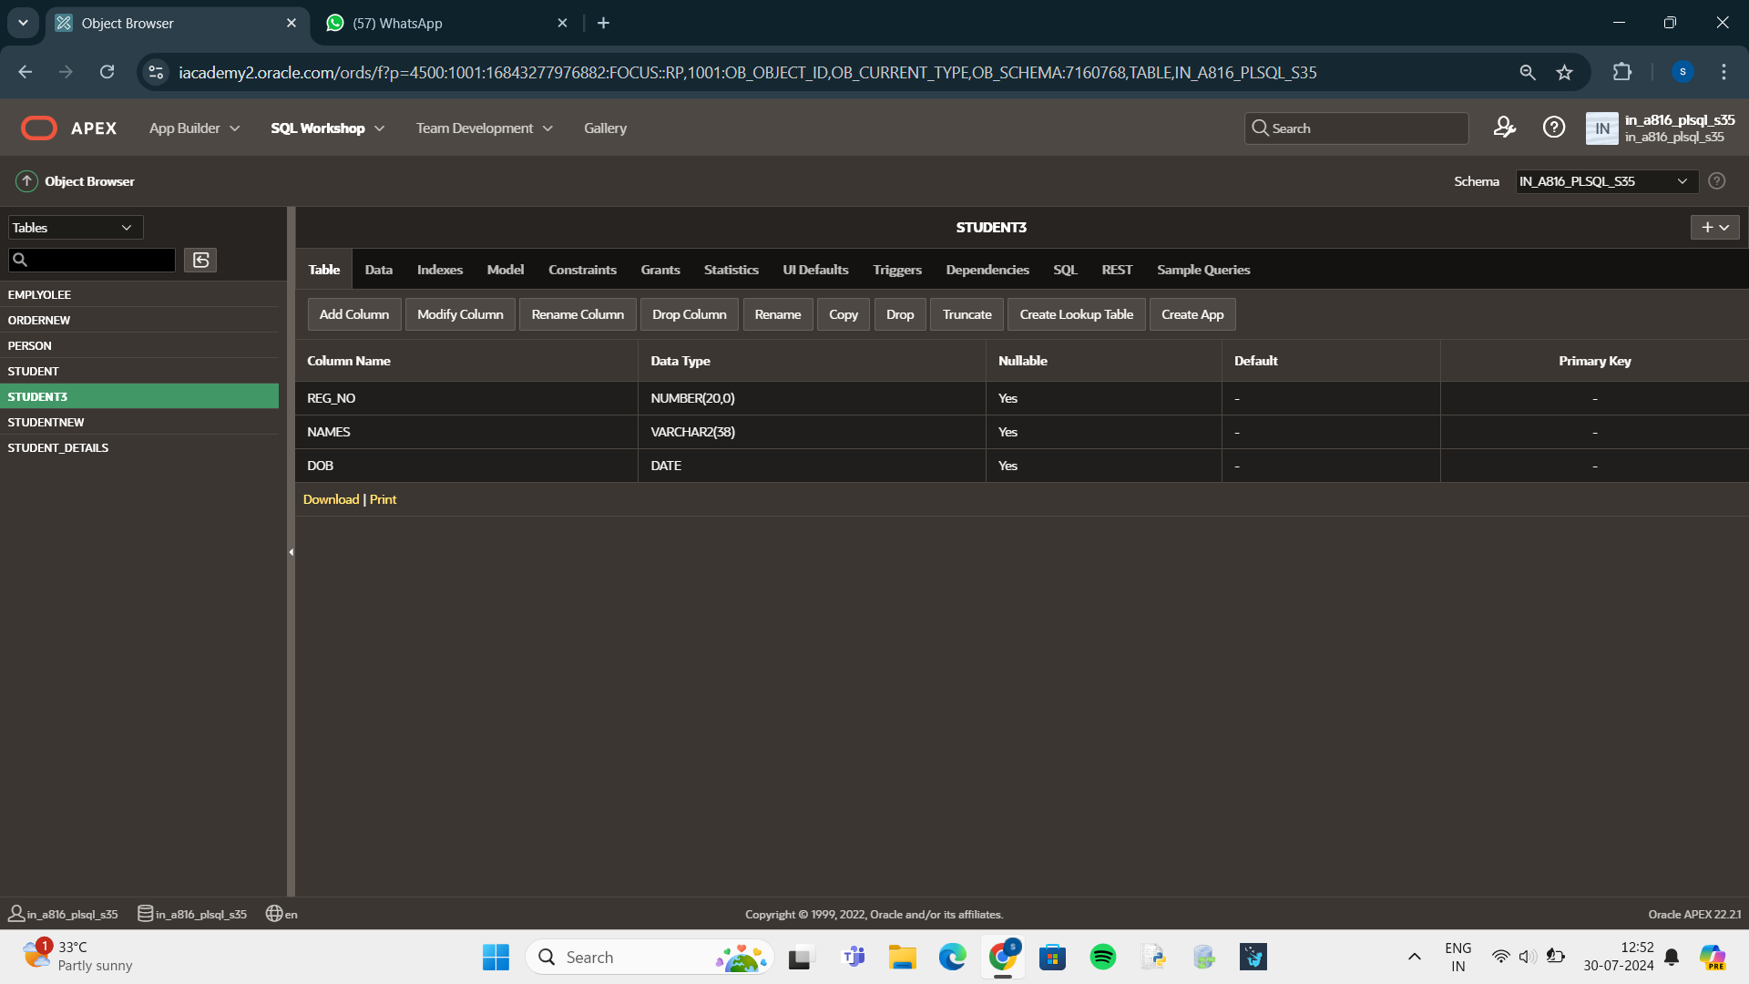

ALTER TABLE STUDENT3

ADD Blood_Group VARCHAR(20);

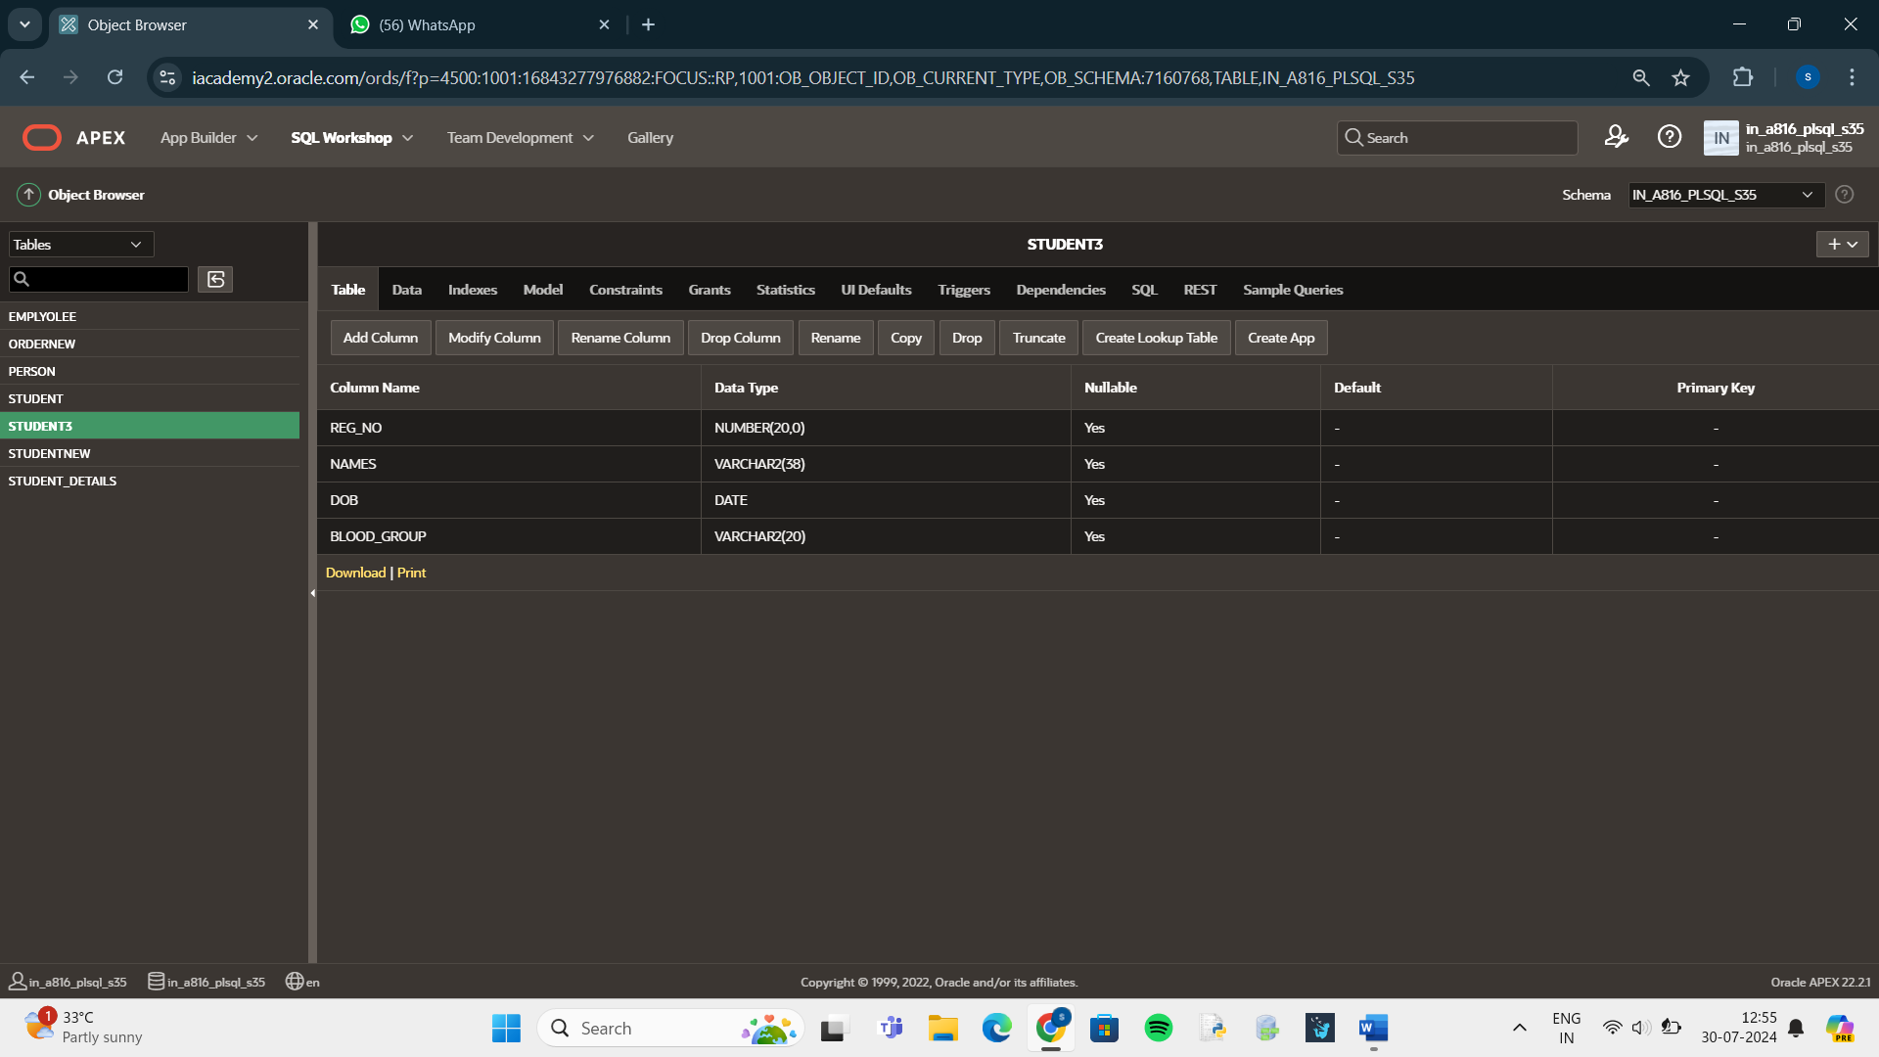

ALTER TABLE STUDENT3 ADD PRIMARY KEY (Reg_No);

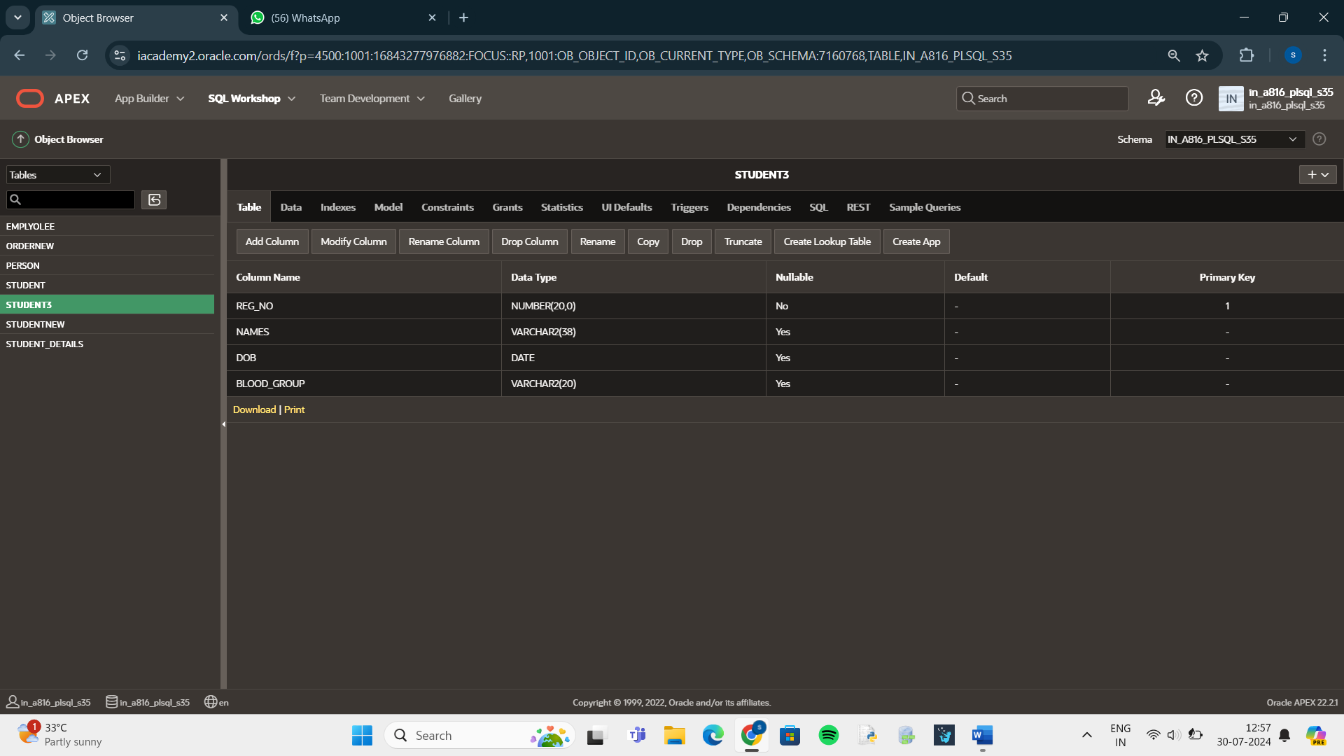

ALTER TABLE STUDENT3

ADD User_ID NUMBER(20);

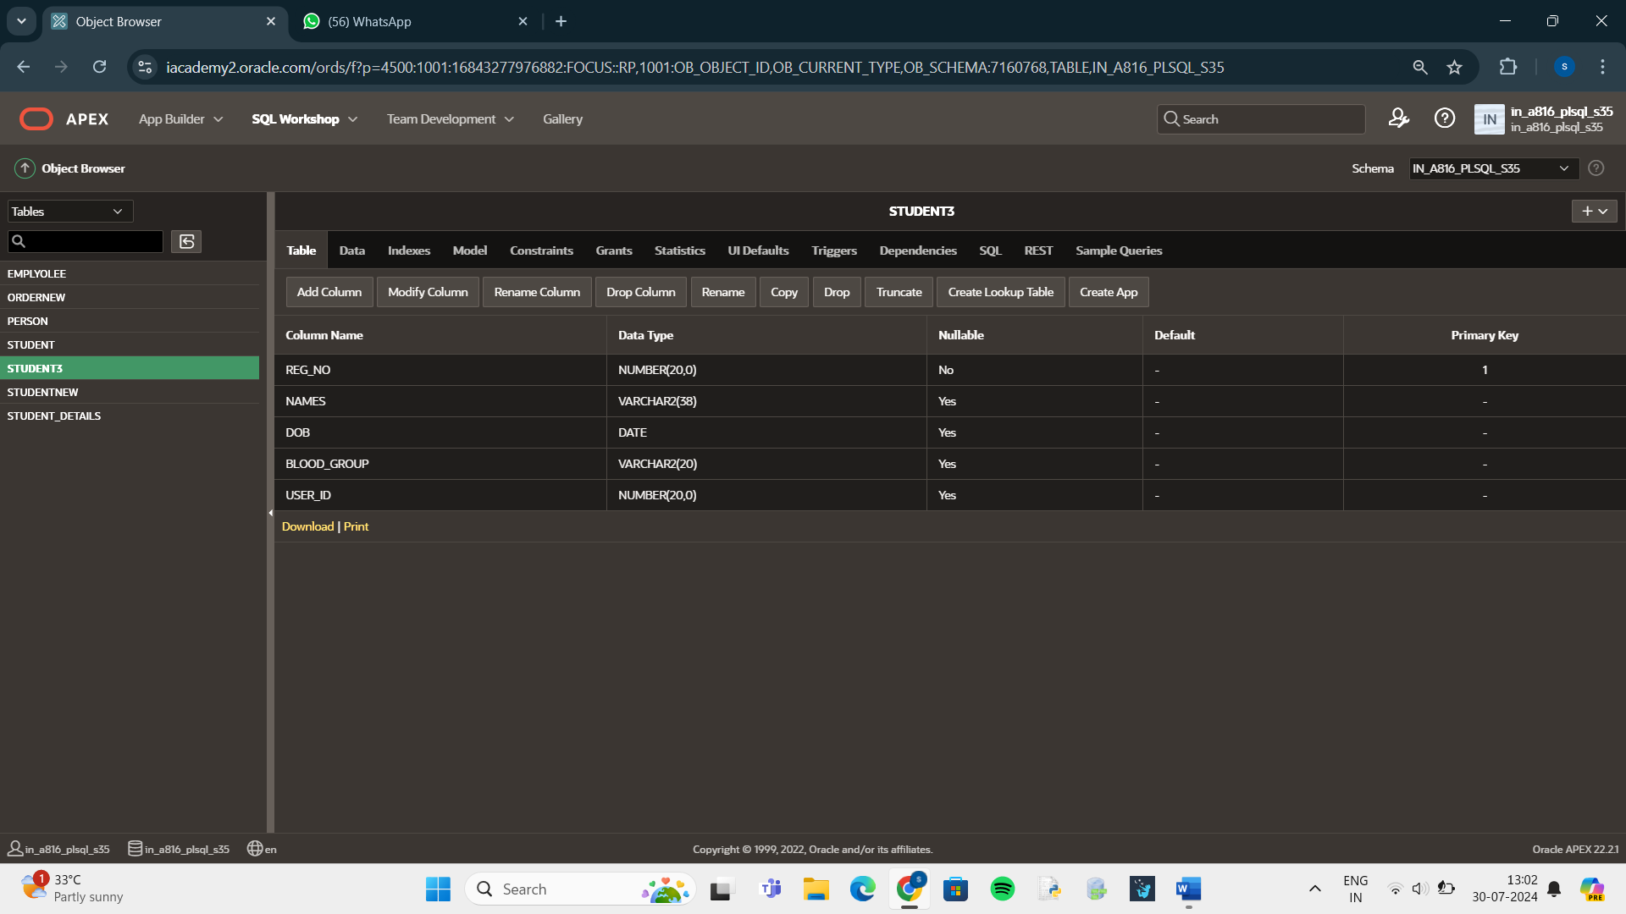

ALTER TABLE STUDENT3

DROP(User_ID);

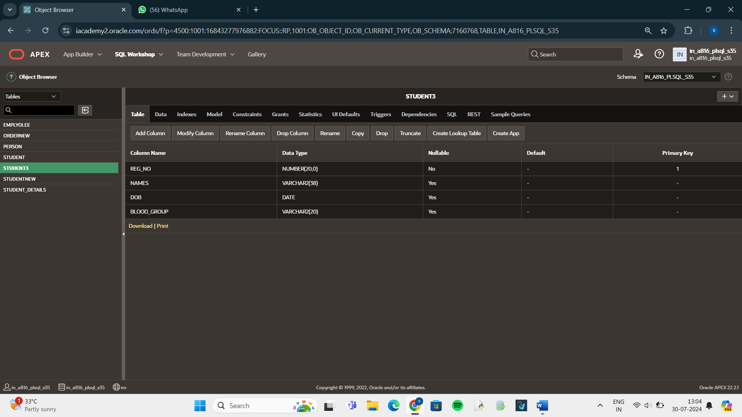

ALTER TABLE STUDENT3

RENAME COLUMN Reg_NO TO Register_No;

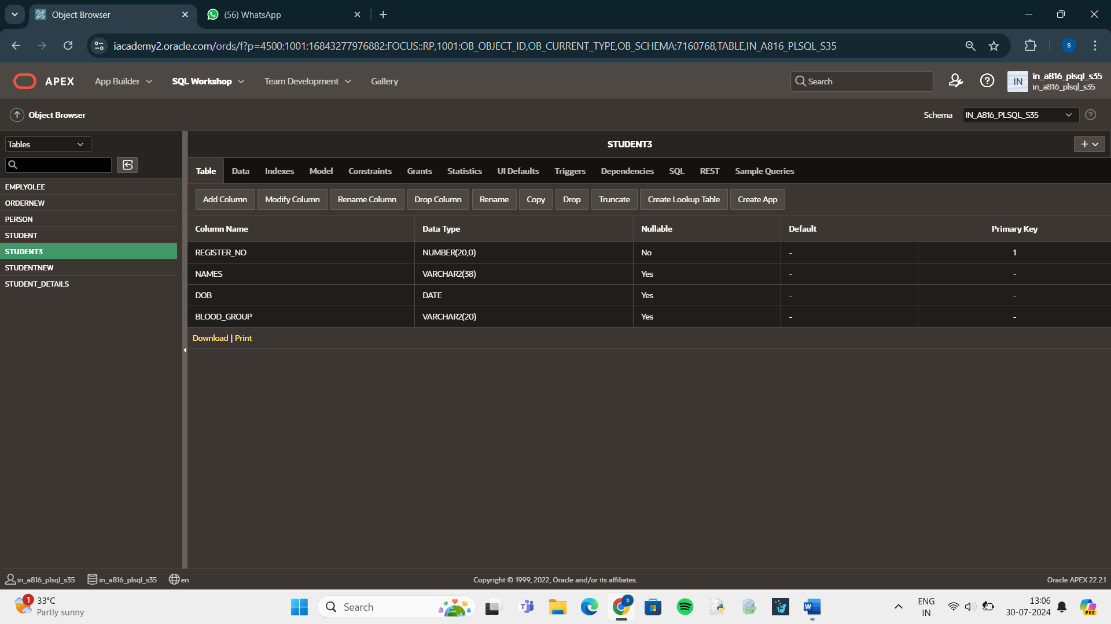

ALTER TABLE STUDENT3

MODIFY Names VARCHAR(38) NOT NULL;

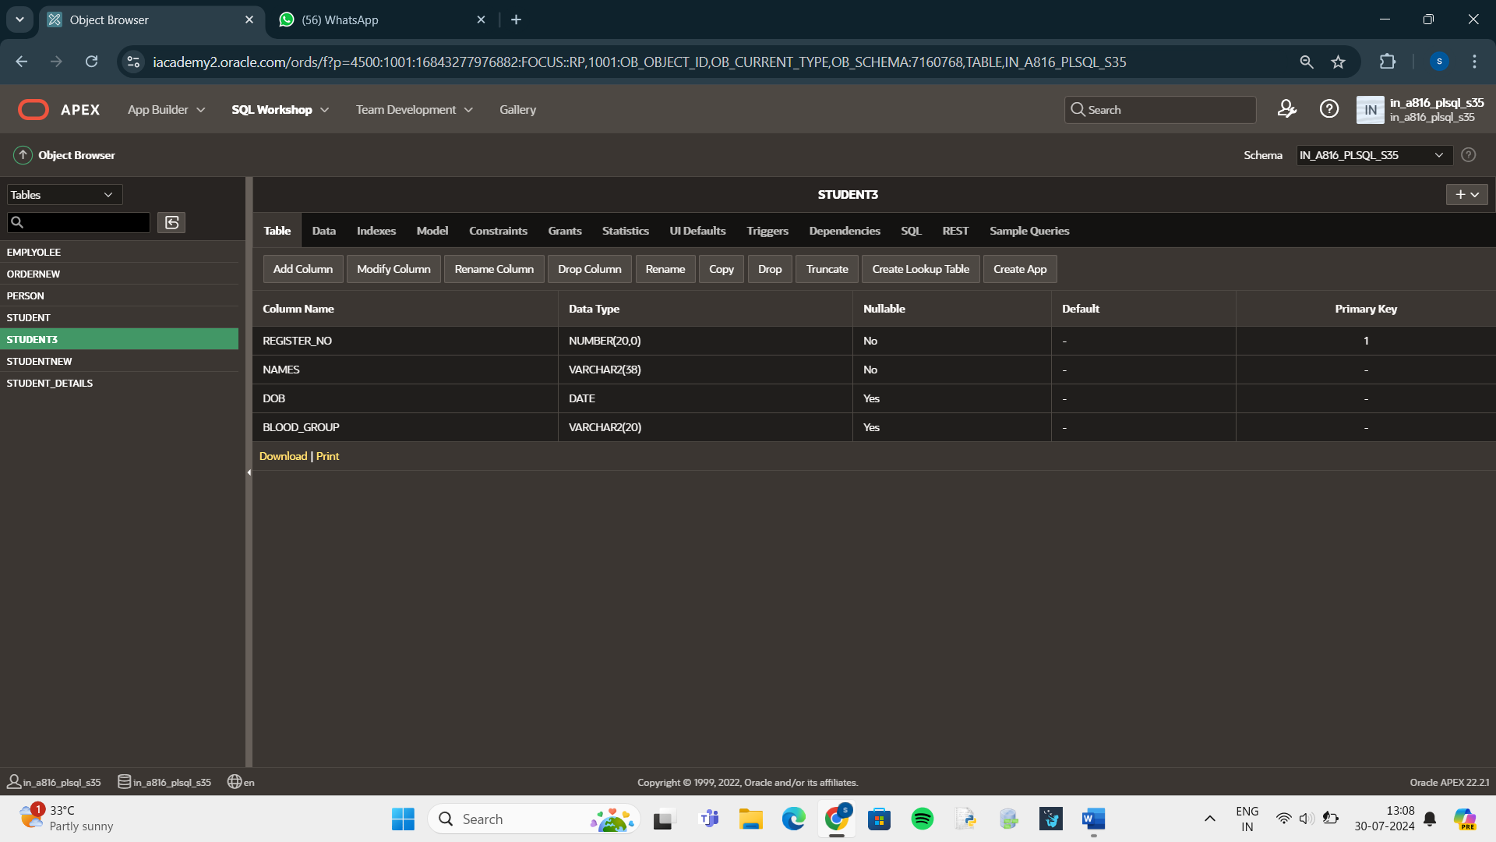

ALTER TABLE STUDENT3

MODIFY DOB NUMERIC NOT NULL ;

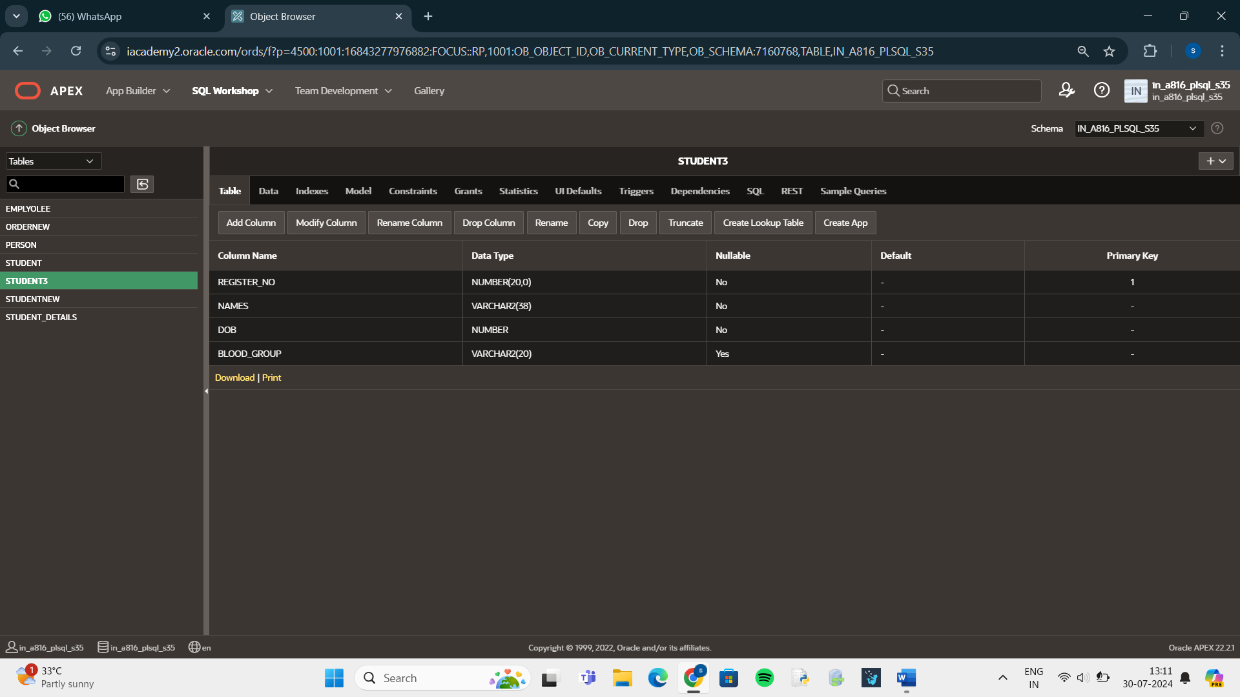

INSERT INTO STUDENT3 VALUES(192321113,'Sarshini',2005,'A');

INSERT INTO STUDENT3 VALUES(192321115,'Sakthi',2004,'B');

INSERT INTO STUDENT3 VALUES(192321111,'Amritha',2005,'B');

INSERT INTO STUDENT3 VALUES(192321105,'Harini',2005,'O');

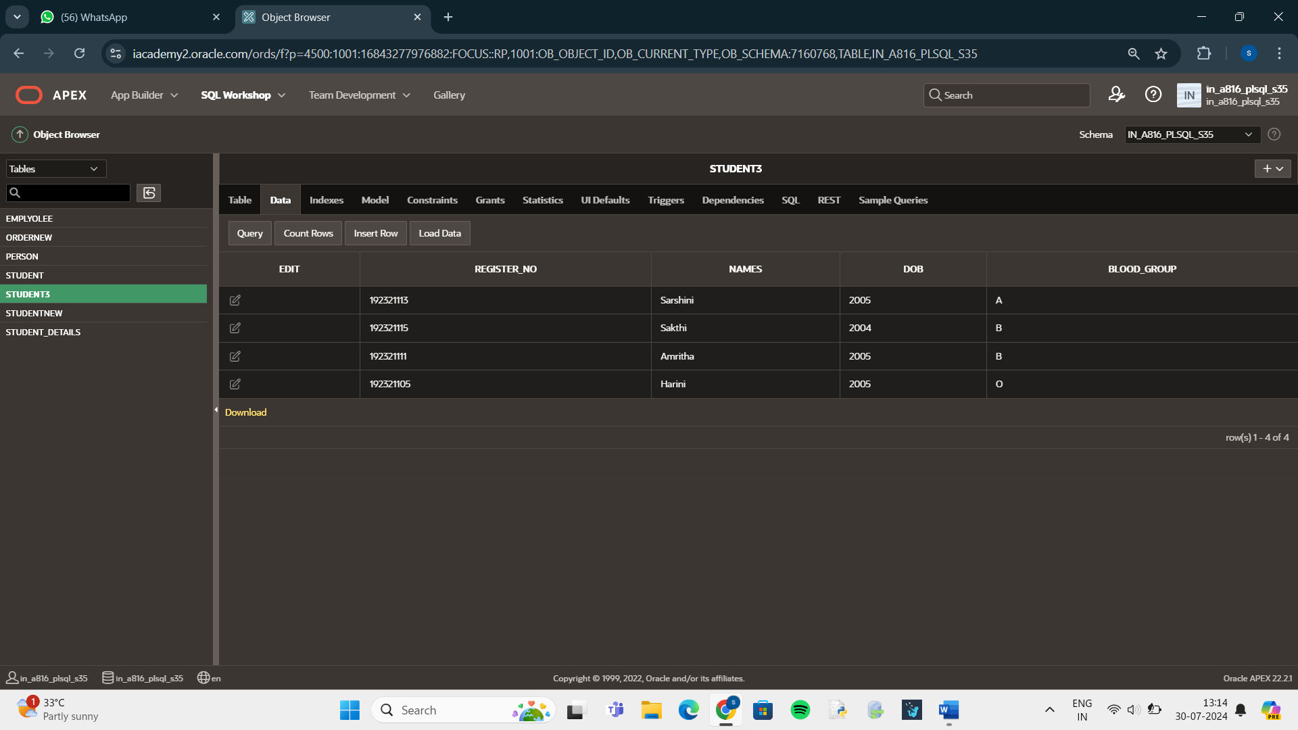

SELECT * FROM STUDENT3

ORDER BY Register_No;

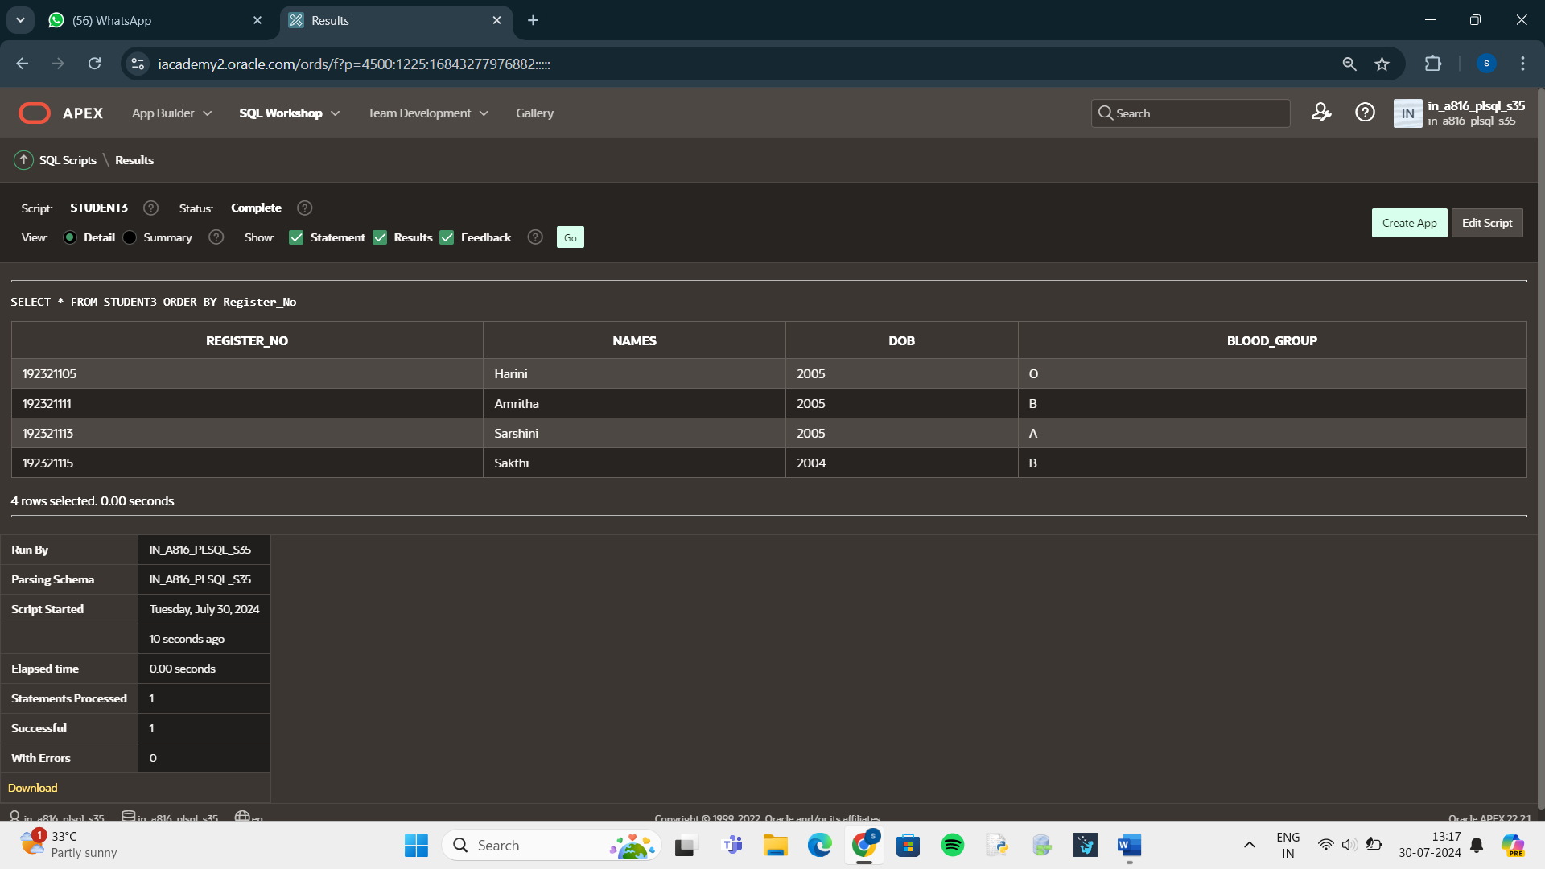

SELECT * FROM STUDENT3

WHERE Register_No BETWEEN 192321113 AND 192321115;

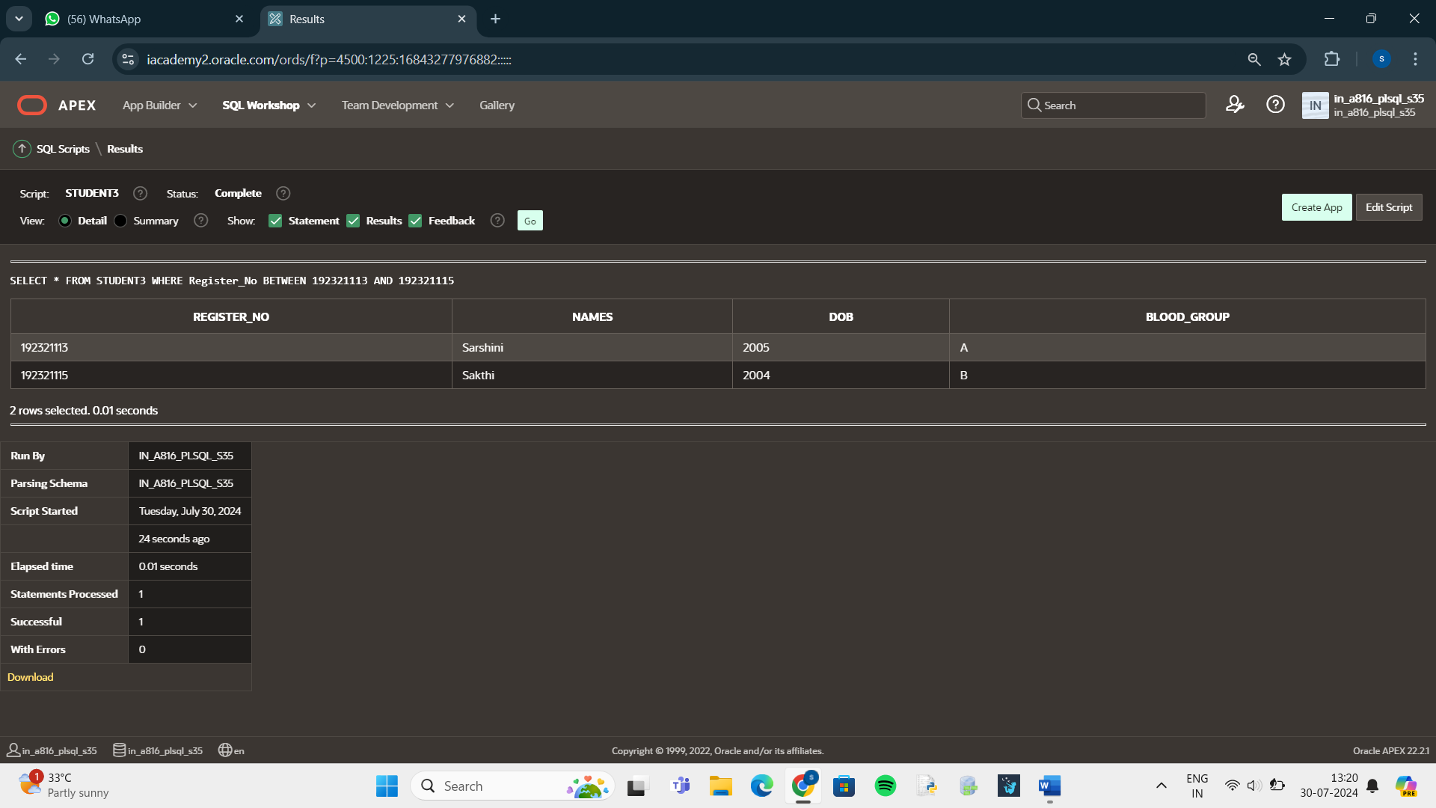

DELETE FROM STUDENT3

WHERE Blood_Group ='B';

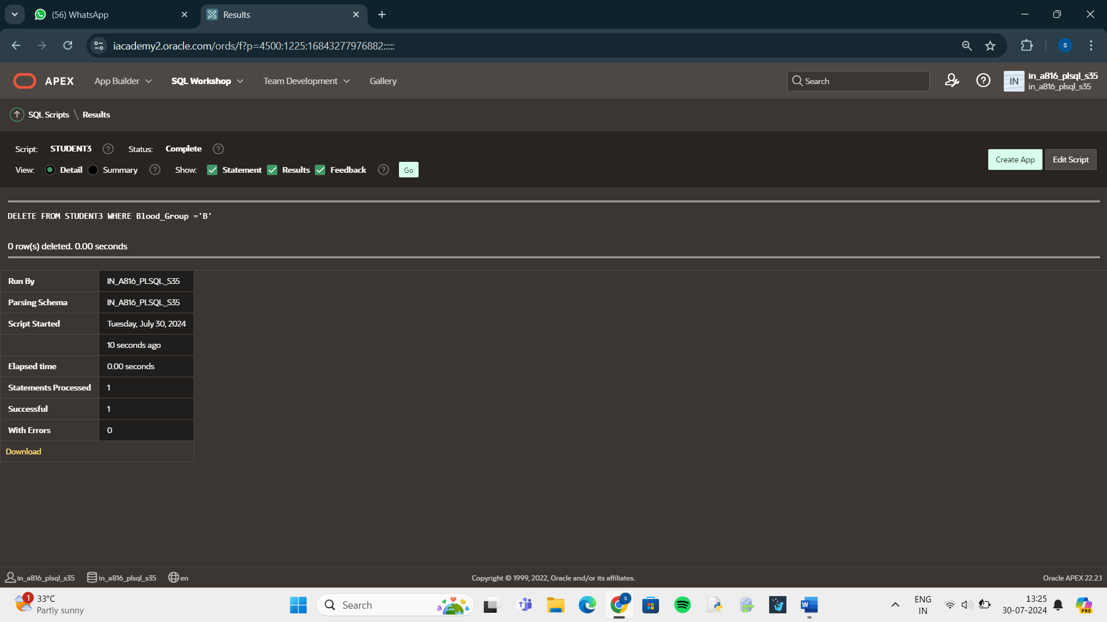

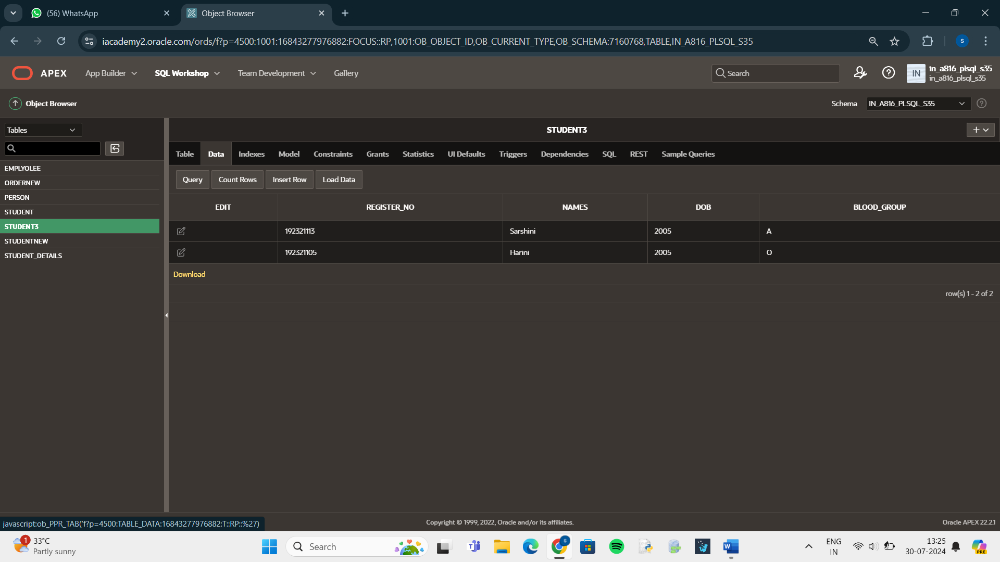

DELETE FROM STUDENT3;

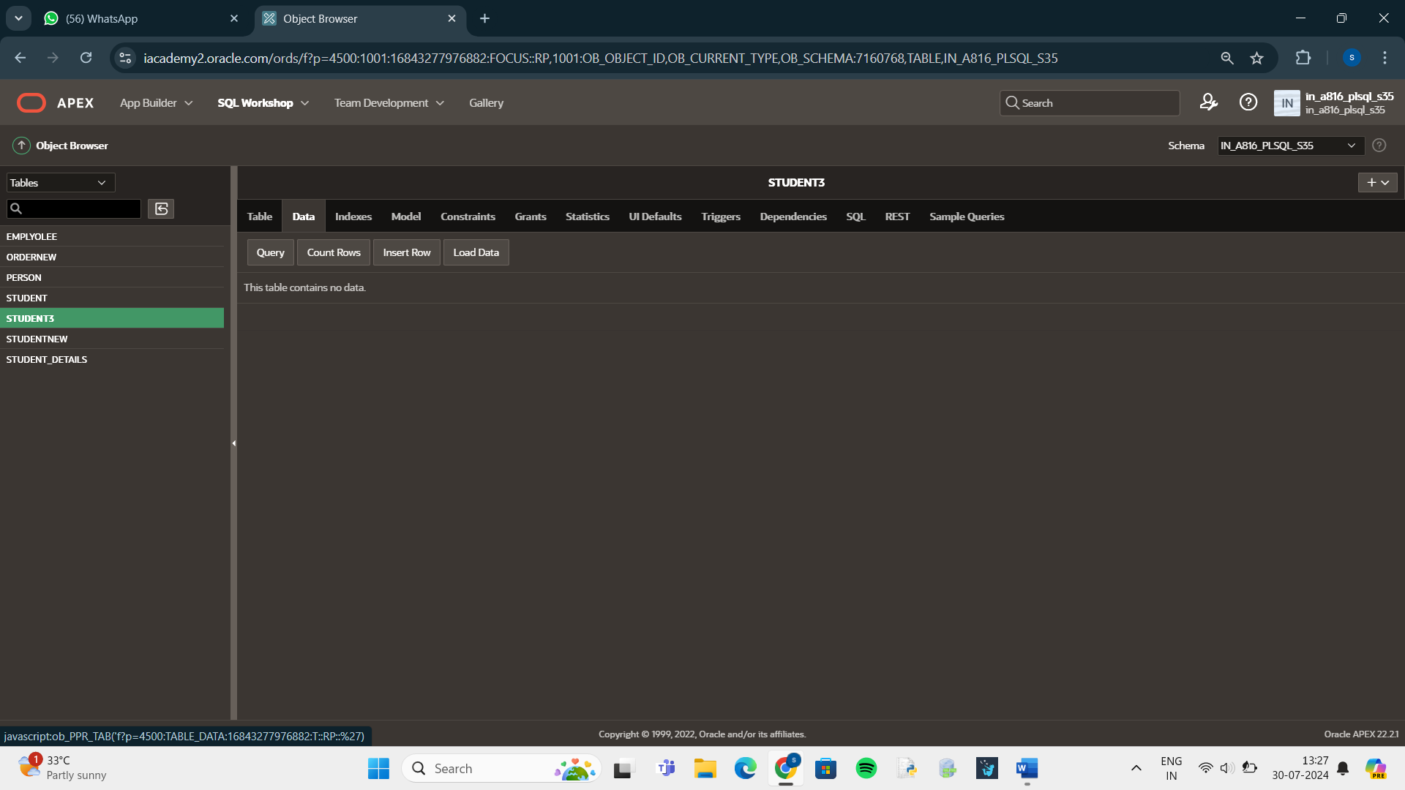

AND:

SELECT Register_No, Date_Of_Birth

FROM STUDENTNEW1

WHERE Register_No >192321111 AND Date_Of_Birth >2005;

NOT IN:

SELECT Register_No, Blood_Group

FROM STUDENT3

WHERE Register_No NOT IN (192321113,192321115);

USING:

SELECT First_Name || Last_Name FROM STUDENT3;

AS:

SELECT First_Name || Last_Name AS Names FROM STUDENTNEW1;

LIKE:

SELECT First_Name

FROM STUDENT3

WHERE First_Name LIKE '% 0%';

ALTER TABLE ORDERNEW ADD FOREIGN KEY (PERSON_ID) REFERENCES PERSON(PERSON_ID);

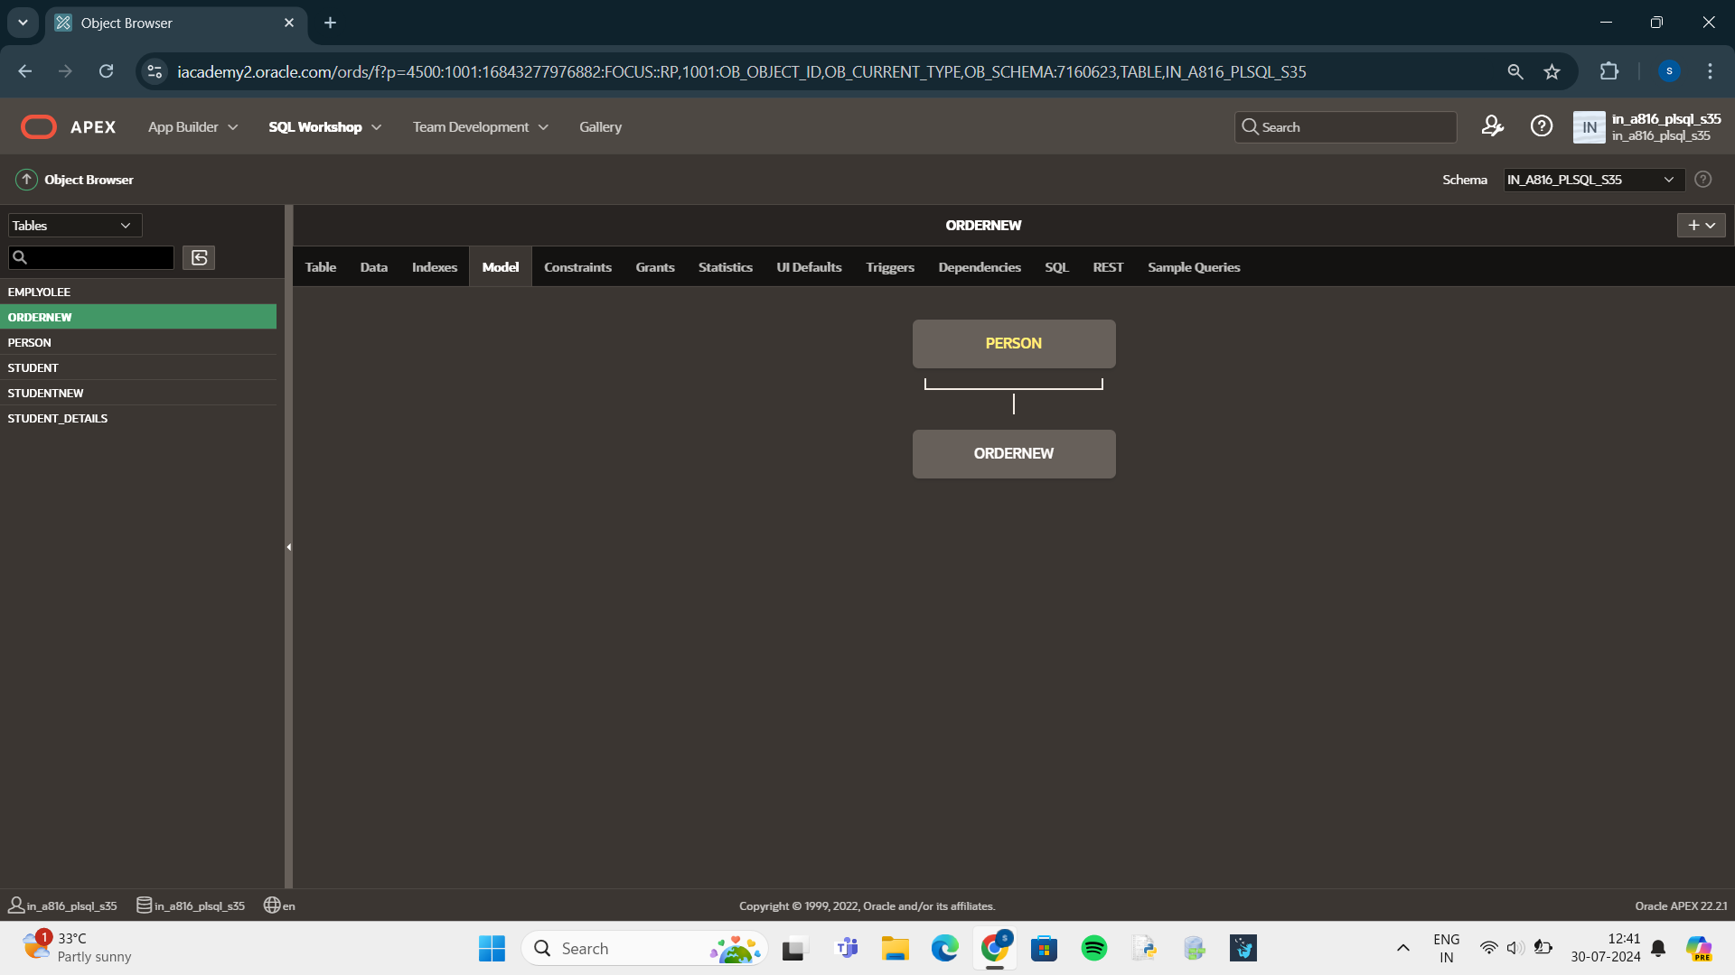

SELECT *

FROM orders

JOIN person

ON orders.person_id = person.person_id;

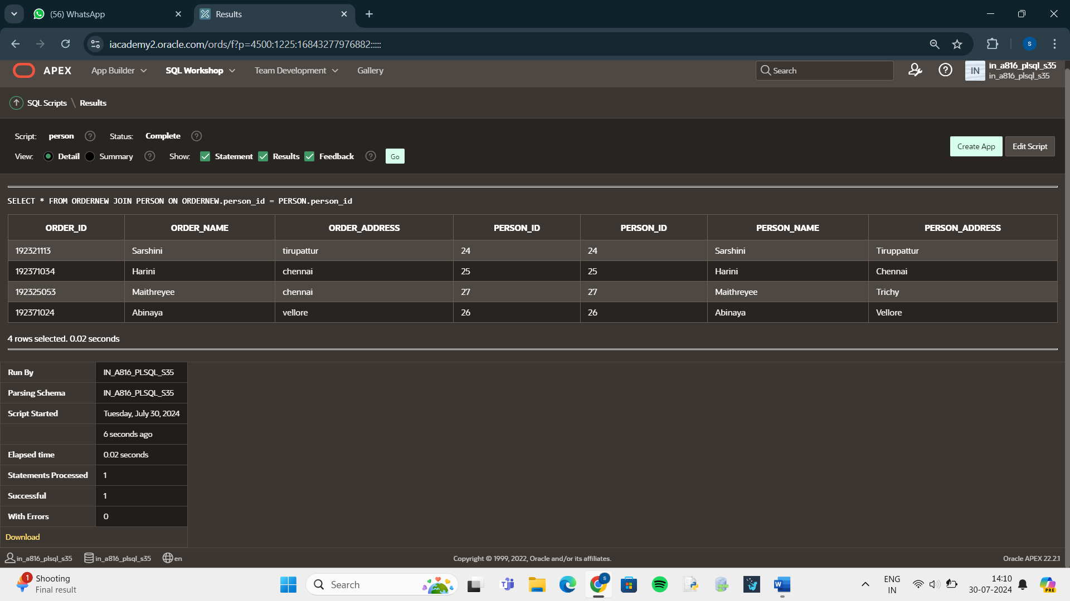

SELECT Order_id, Order_name,Order_Address

FROM ORDERNEW NATURAL JOIN Person

WHERE Person_id > 20;

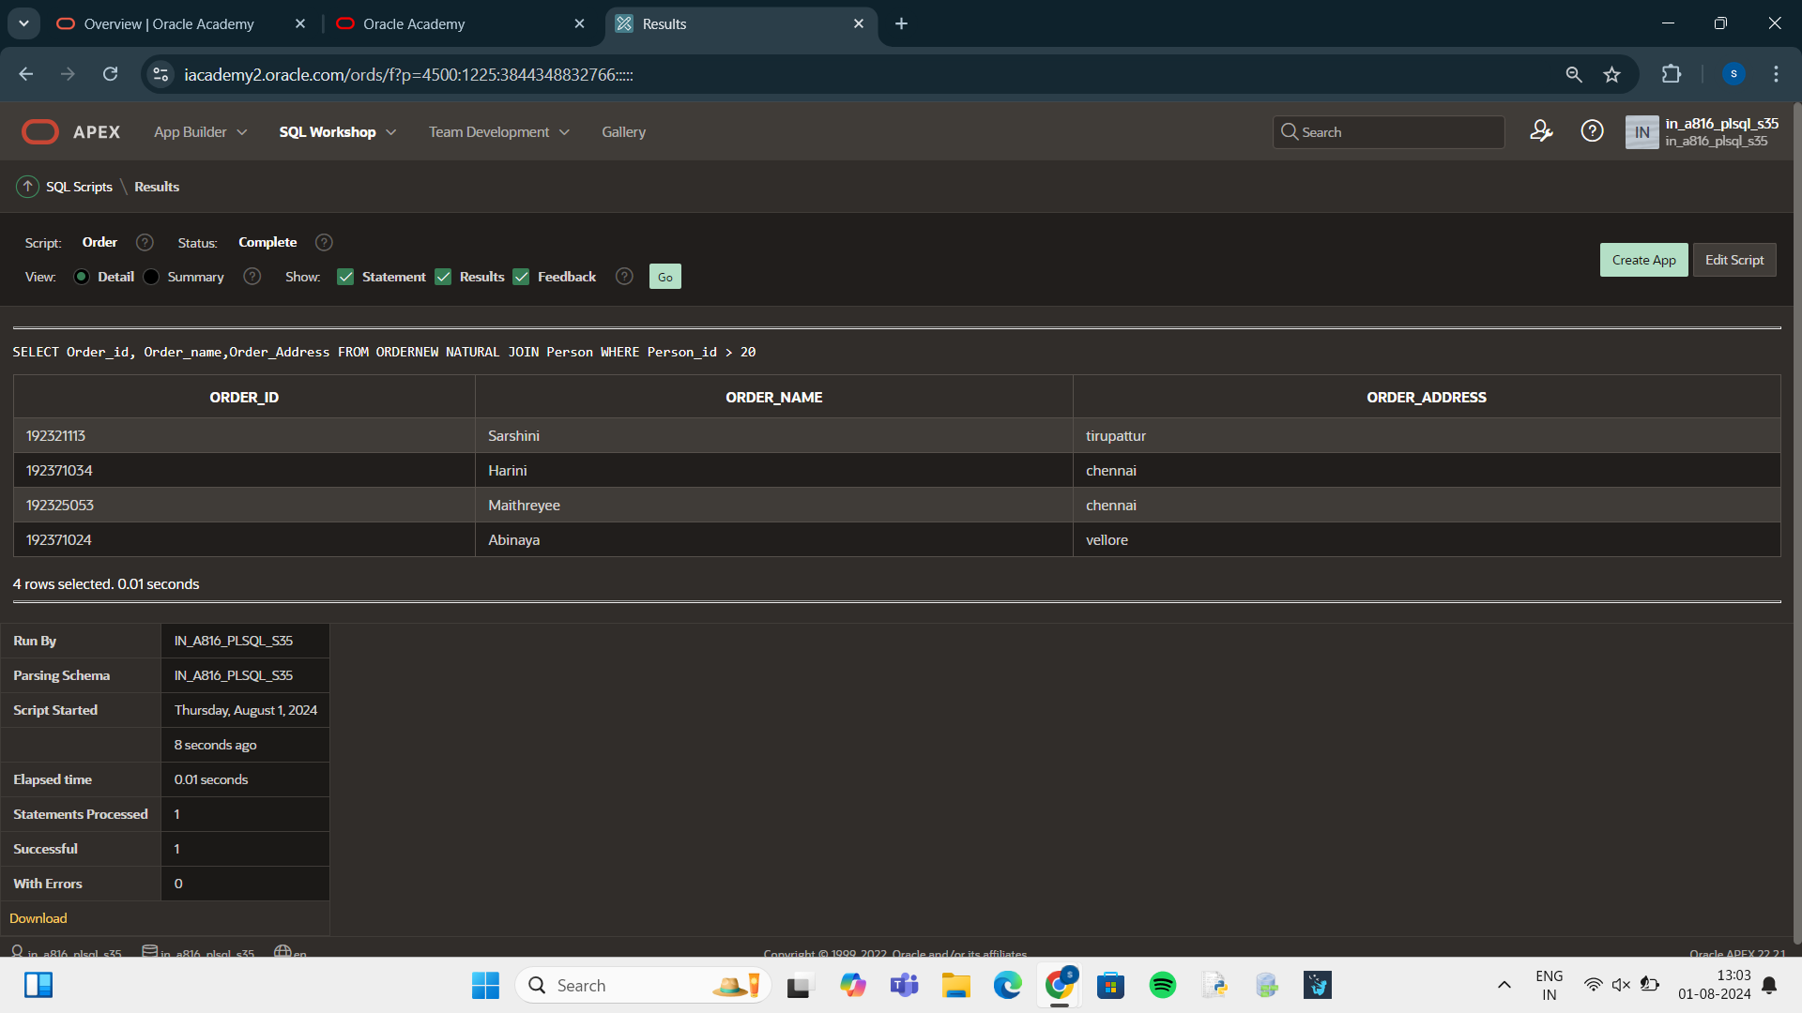

select Order_id,Order_name,Order_address,Person_id

FROM ORDERNEW JOIN PERSON USING(PERSON_ID);

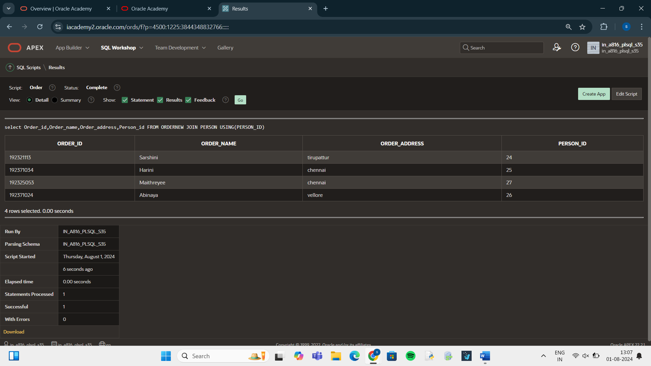

select Order_id,Order_name,Order_address,Person_id

FROM ORDERNEW JOIN PERSON USING(PERSON_ID)

WHERE Order_name='Abinaya';

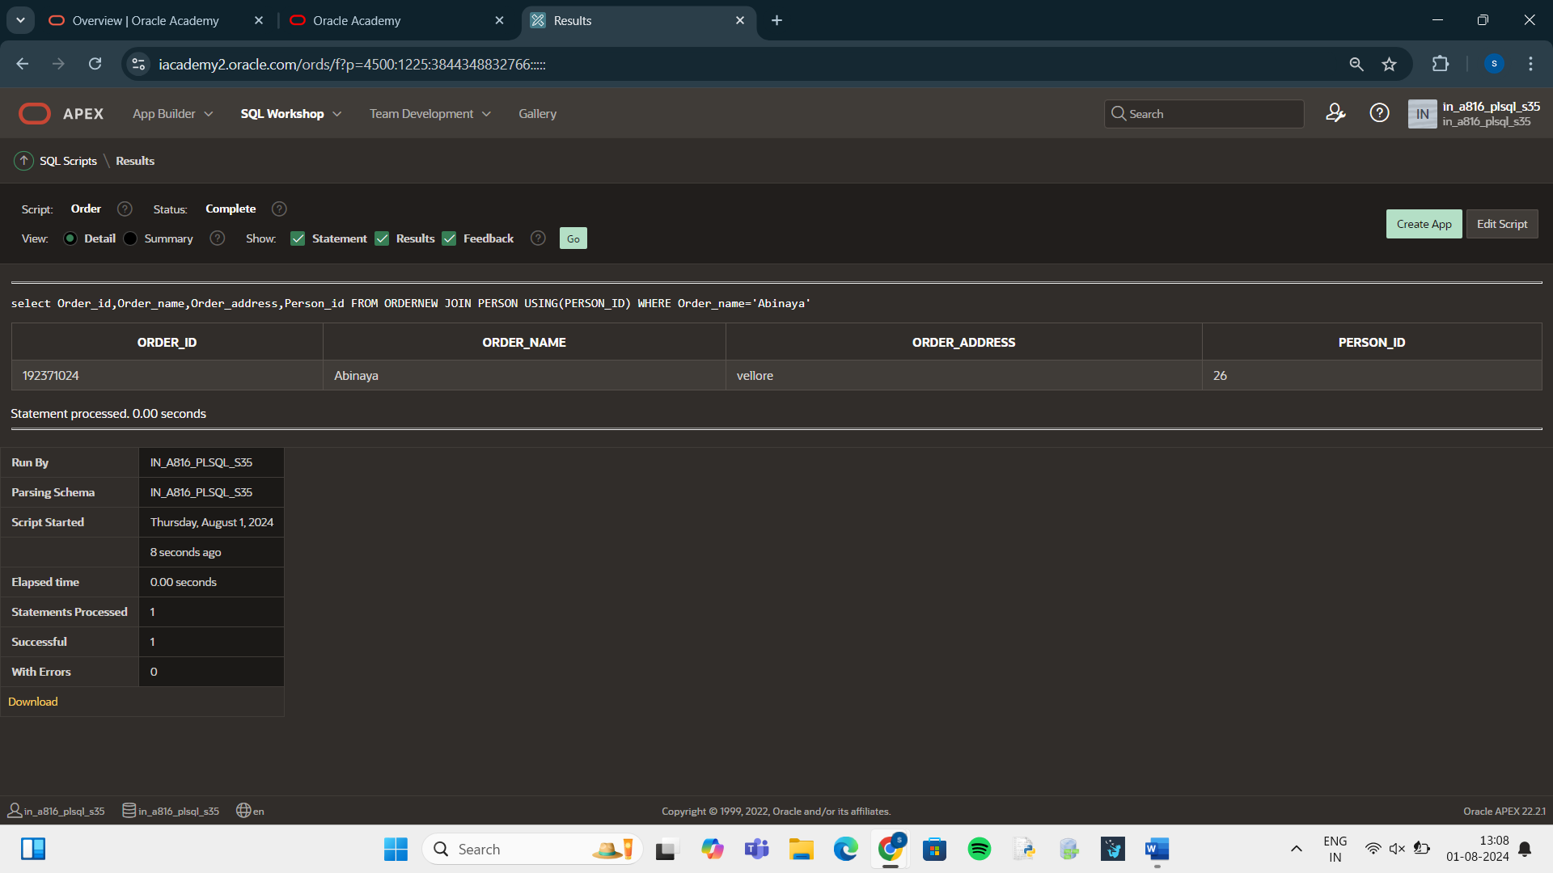

SELECT O.ORDER_ID,P.PERSON_ID,P.PERSON_NAME

FROM ORDERNEW O LEFT OUTER JOIN

PERSON P

ON(O.PERSON_ID=P.PERSON_ID);

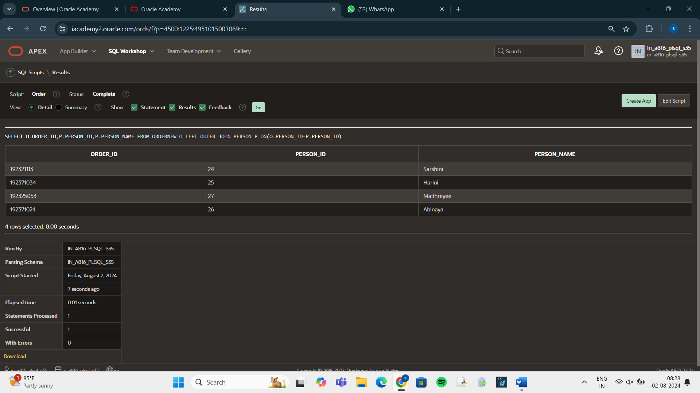

SELECT O.ORDER_ID,P.PERSON_ID,P.PERSON_NAME

FROM ORDERNEW O RIGHT OUTER JOIN

PERSON P

ON(O.PERSON_ID=P.PERSON_ID);

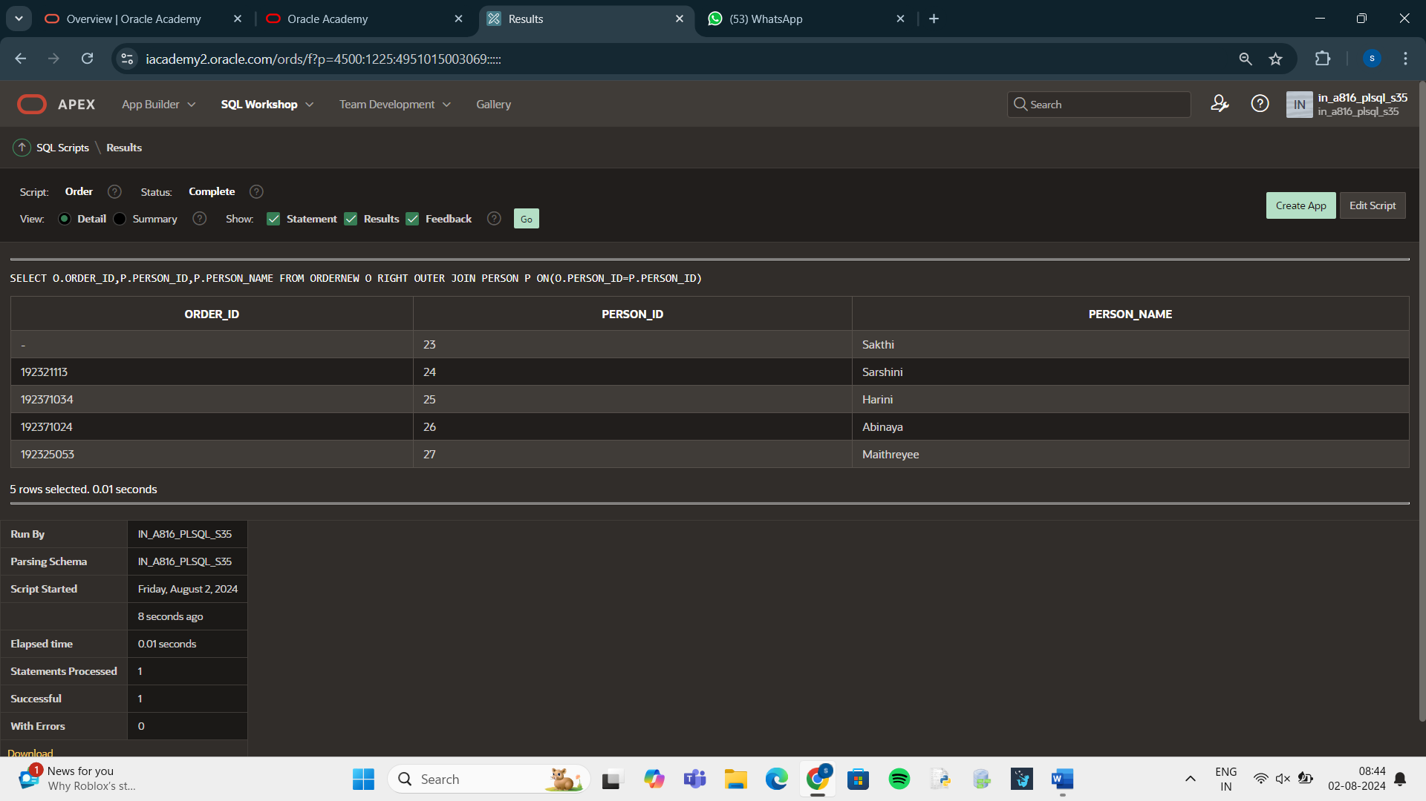

SELECT ORDER_NAME,ORDER_ID

FROM ORDERNEW CROSS JOIN

PERSON;

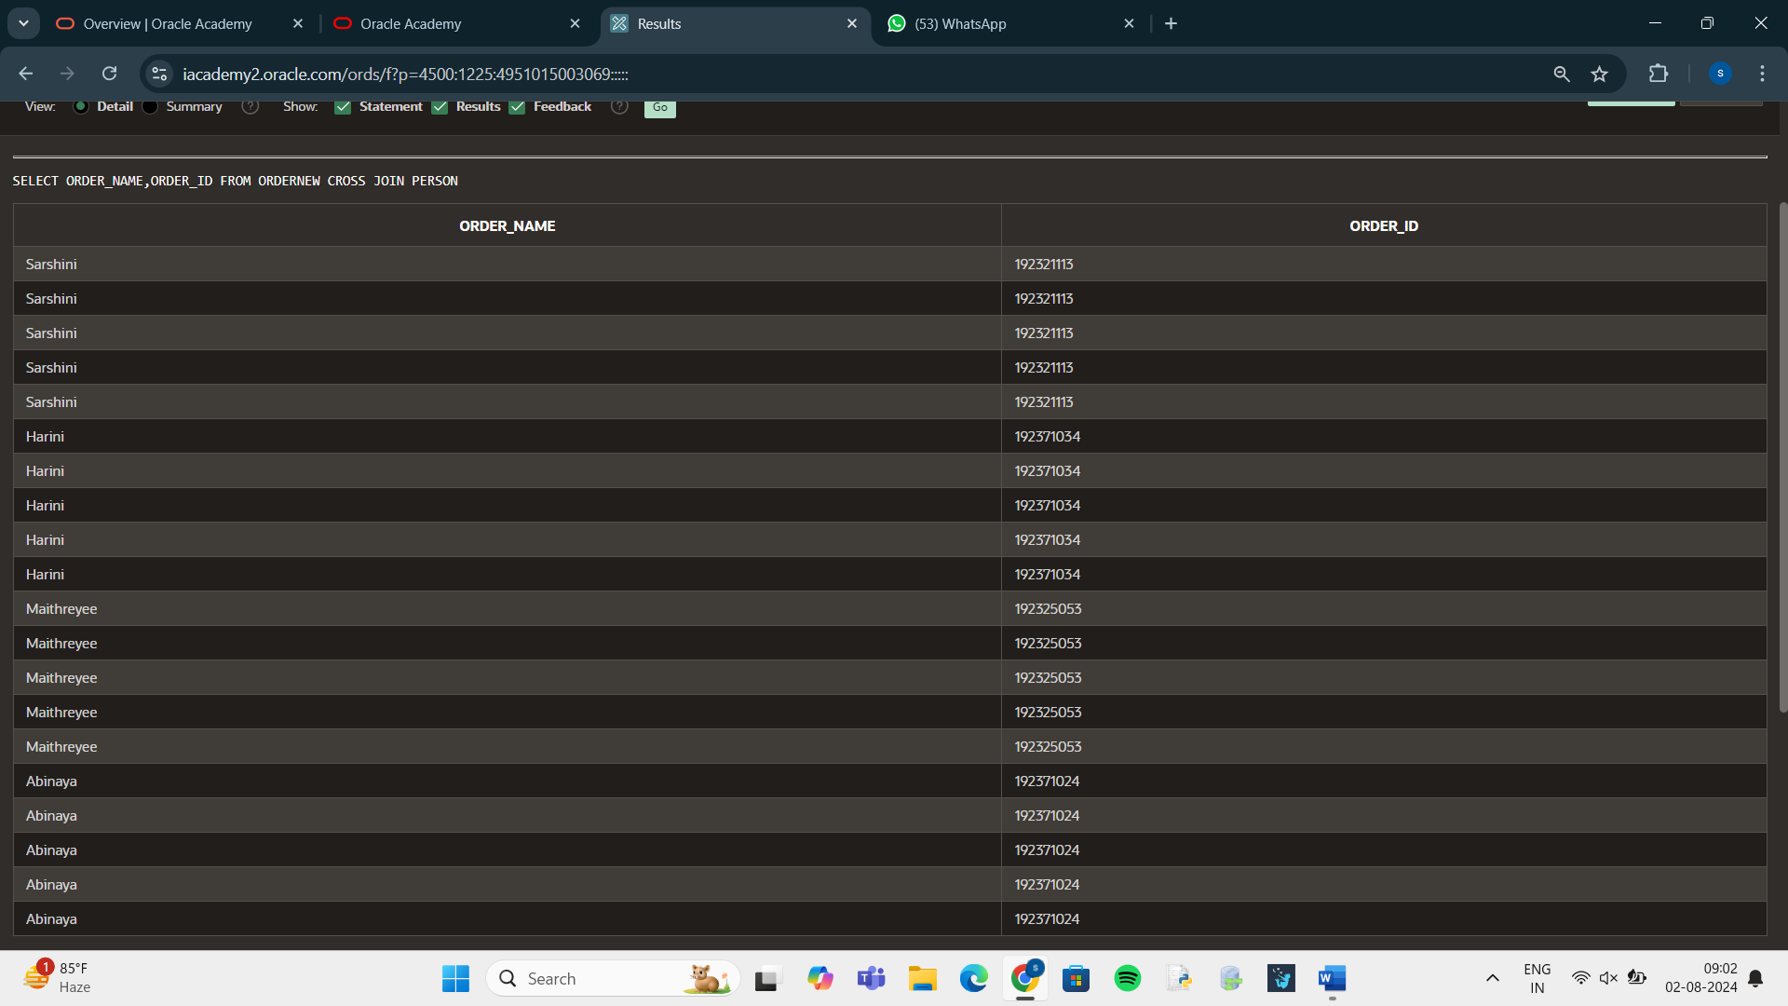

SELECT O.ORDER_ID ||'WORKSFOR'||P.PERSON_NAME

AS "WORKSFOR"

FROM ORDERNEW O JOIN PERSON P

ON (O.PERSON_ID=P.PERSON_ID)

